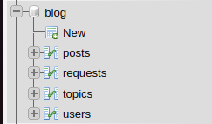**Database has name: blog**

It has 4 tables:

1. posts
2. requests
3. topics
4. users

**Table name: posts**

Structure: 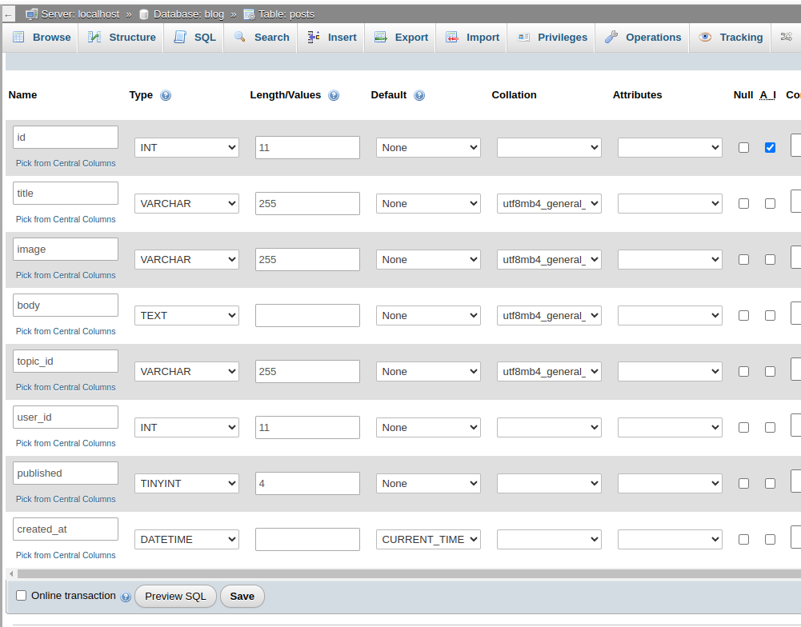

_________________________________________________________________________

**Table name: requests**

Structure:

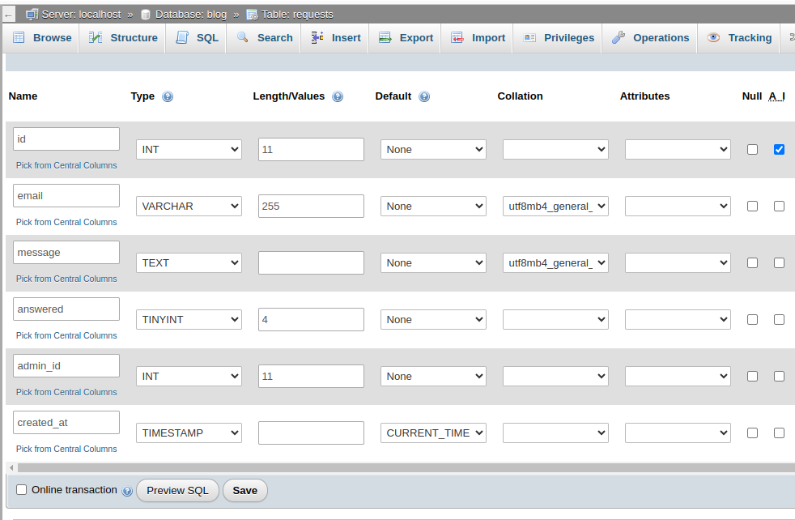

_________________________________________________________________________

**Table name: topics**

Structure:

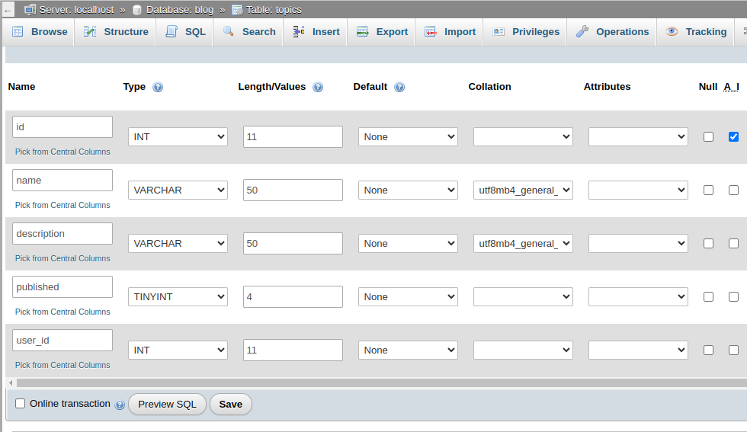

_________________________________________________________________________

**Table name: users**

Structure:

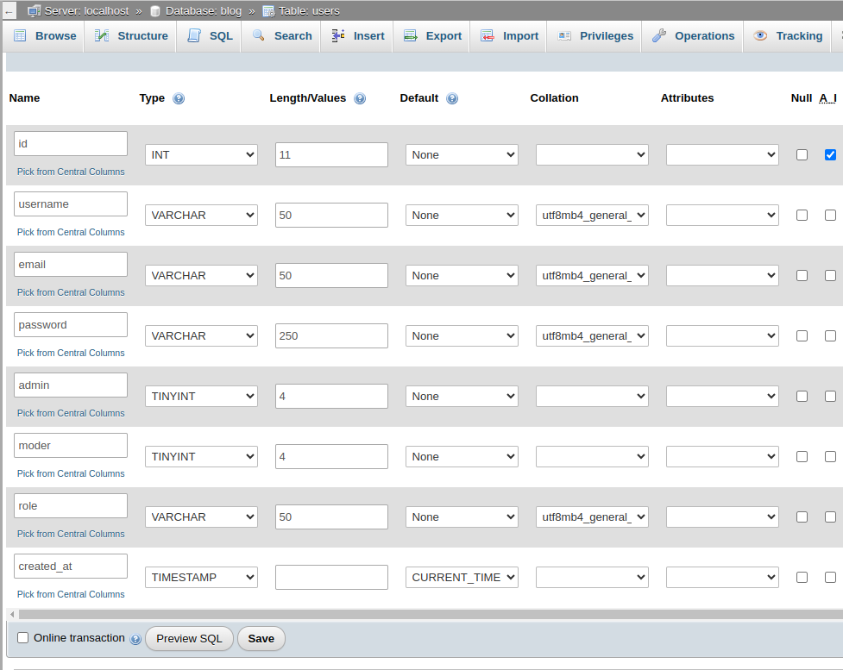

_________________________________________________________________________

**Also don’t forget to change settings inside */blog/app/database/connect.php***

Fill up them due to configurations on your PC

